**The 7th of April.**

**Сlasswork.**

1. **Read the tale.**

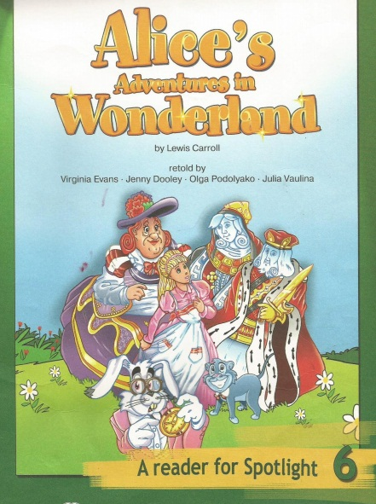

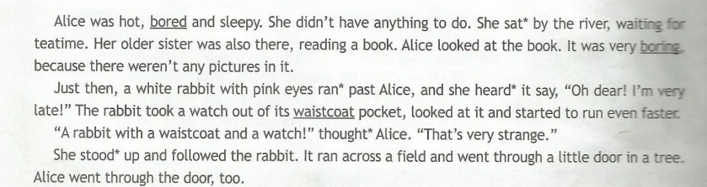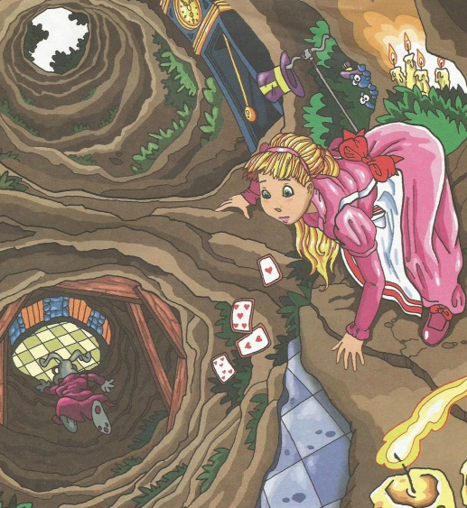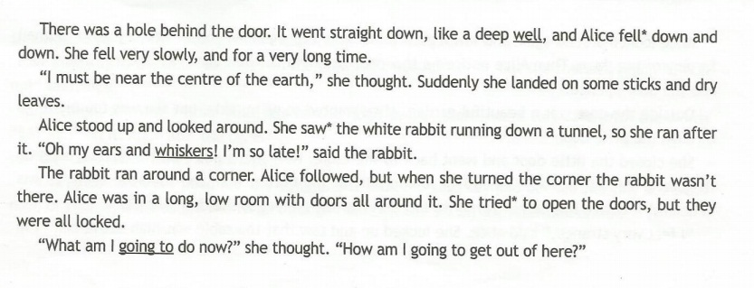

**Homework.**

**Name______________________ Class__________**

**На основании прочитанного, выполни упражнения.**

